Artificial Intelligence (Lab)
Mr. Rasikh Ali
Name: Afaq Akhtar
Roll No:SU92-BSSEM-S25-060

The Superior University
AI Lab Tasks
Lab 06
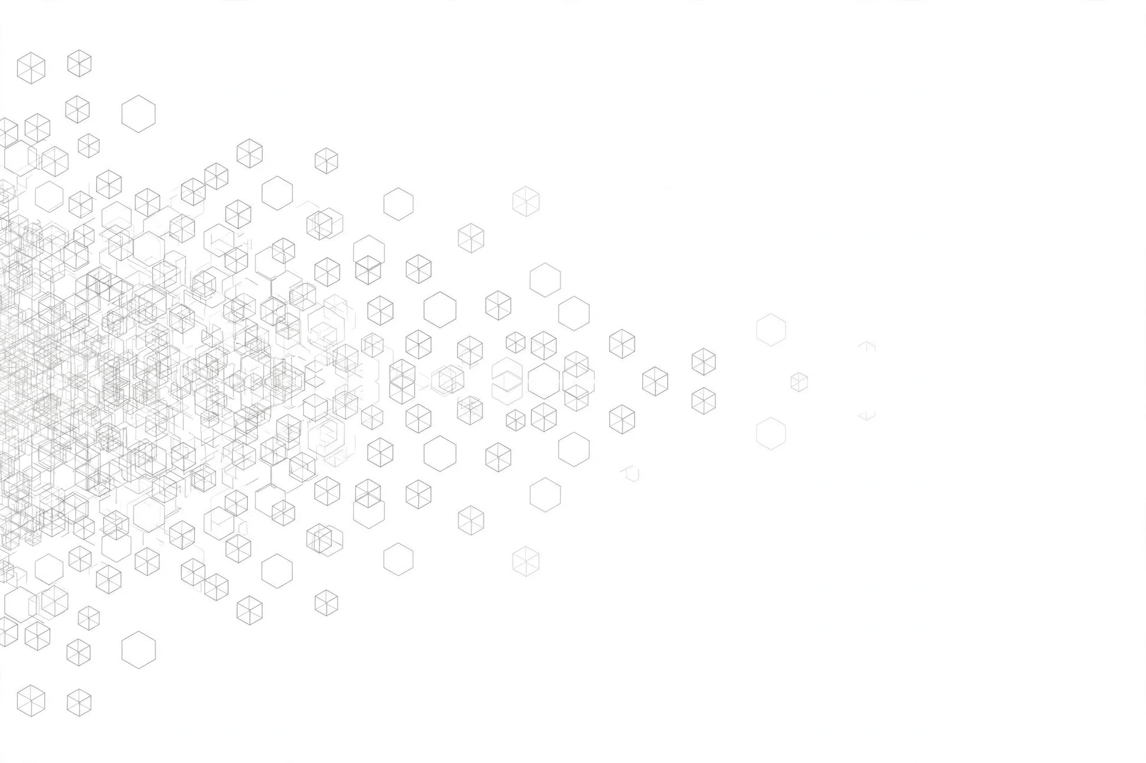

Lab 6
NLP Fundamentals: Tokenization, Embeddings & Text Chunking

Task 1
Code Implemetation is in attached file named with Lab 6 Task 1.ipny
Output Explanation
In this task I split text into tokens in three ways. Whitespace splitting is simple, but it keeps punctuation with the word, like "search!". The regex method gives clean words, but it breaks some things. It splits "can't" into "can" and "t". It splits the email into 3 parts. It also splits "2.1" into "2" and "1". The empty text gives 0 tokens in both methods, which is correct. The Urdu line gives 4 tokens in both methods. The model tokenizer is different from both. It uses small subwords, it makes all letters small, and it keeps punctuation as separate tokens. This means our simple tokens are not the same as the model tokens.
In the chatbot part, an exact question gets a direct answer with its source. For example, the password question gives the answer with [source: it_help.txt]. A short question like "password recovery" does not get a direct answer. The bot shows possible matches and asks me to choose. An empty input gives "Please enter a question." A wrong topic like "volcano geology" gives "No matching FAQ." In the end, all checks passed. The bot works like this because a score alone cannot prove that an answer is correct, so the user must confirm first.
Task 2 —
Code Implemetation is in attached file named with Lab 6 Task 2.ipny
Output Explanation
In this task I made text chunks in two ways and compared them. First, all the reference checks passed. This means every chunk text matches its source text exactly. In the boundary tests, empty text gives no chunks. A short document gives only 1 chunk. Wrong overlap gives an error, which is good because wrong settings are stopped. One long sentence of 95 words is split into 3 chunks of 40, 40 and 15 words, so the 40-word limit is never crossed.
My three documents have 208, 192 and 183 words. In the comparison table, windows with overlap 0 make 16 chunks and copy 0 words, but they cut the exception sentence into two parts, so the full evidence is lost. Windows with overlap 10 make 20 chunks and keep the rule and the exception together, but they copy 170 extra words. Sentence-aware chunks also make 20 chunks and copy 0 words, and every sentence stays full and safe. But the rule and the exception come in two different chunks, because of the 40-word limit. The demo also shows a weakness: the simple splitter cuts wrongly after "Dr." and "e.g.", because it cannot understand abbreviations.
In the semantic check, both TF-IDF and embeddings give the IT record first. But the embedding gap is bigger: 0.526 against 0.021. TF-IDF gives 0.343 against 0.000. This is because TF-IDF matched only the common word "can", but embeddings matched the meaning of the question.
Task 3
Code Implemetation is in attached file named with Lab 6 Task 3.ipny
Output Explanation
In this task I tested the full search system. I used 6 documents and 10 questions. Four questions were for development, four were for final testing, and two questions had no answer in the documents. The model loaded in about 1.8 seconds. The biggest chunk had only 54 model tokens, and the limit is 256, so nothing was cut by the model. The system wrote all results in retrieval_log.csv, 180 rows, so every result can be checked with its source.
Hit@3 means the correct evidence came in the top 3 results. MRR@3 means how high that evidence came. The best result was sentence-aware chunks with embeddings: dev (1.0, 0.875) and test (1.0, 0.75). So I selected this setting for the chatbot. TF-IDF was weak on the test questions (only 0.25), because it cannot match questions that use different words, like "hand in my coursework".
Some failures were also clear. With overlap 0, the window cut the evidence sentence into half, so the answer was lost. The old archived document also came first for the password question (0.736), above the new correct text. This shows that similarity cannot tell which document is new and which is old. The two questions with no answer still got a top result, but with a very low score. In the chatbot, the user sees the candidate chunks with their source and character numbers, and picks one to read. If the user picks nothing, the bot gives no answer. This design is safe, because the bot shows evidence but does not claim it is a verified answer.

